

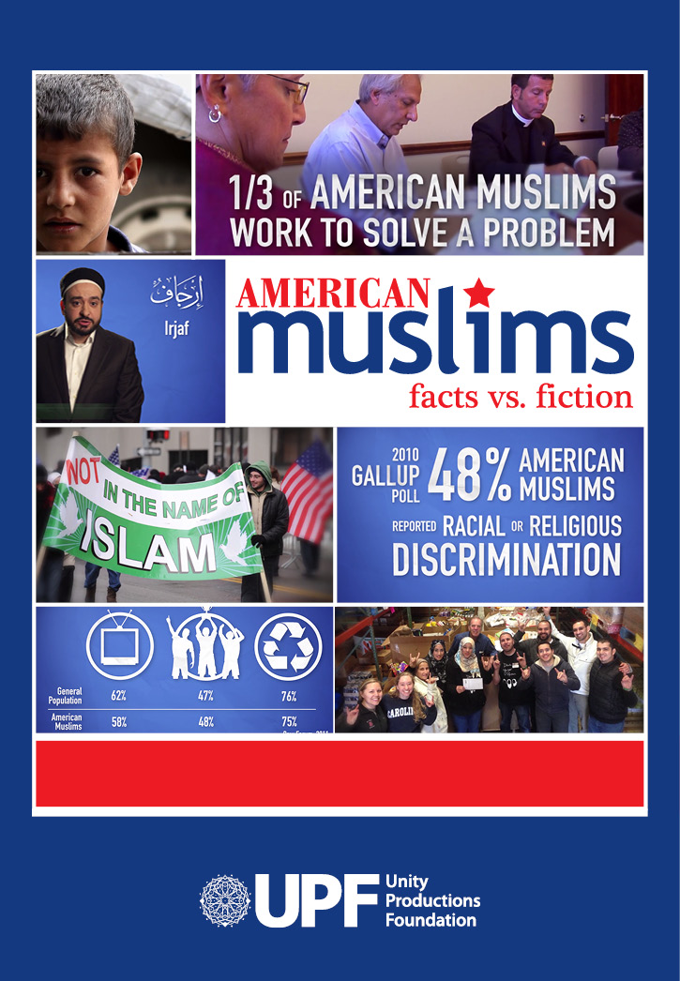

Teacher Discussion Guide

Created by Unity Productions Foundation. Copyright 2016.

About the Film
American Muslims: Facts vs. Fiction (www.americanmuslimfacts.com) presents data collected from reputable polling agencies and think-tanks like the Gallup Organization, the Pew Forum, the Institute for Social Policy and Understanding, and the U.S. Counterterrorism Center. The film examines topics such as prejudice, integration, terrorism, community service, religiosity and more.

Before Viewing the Film
You can use the questions to conduct a straw poll of the group to assess participants’ prior knowledge of and attitudes toward Muslims. This will establish a baseline for comparison with any changes in perception after viewing the film. Alternatively, you may have participants individually note down their responses to the questions below before viewing the film, and discuss any changed perceptions in a short reaction paper (no more than 2 – 3 paragraphs).

Film running time: 11 minutes

Viewing the Film

1. As you watch the film, note down at least 2 – 3 specific pieces of data that you found surprising, compelling or disturbing.

2. The documentary American Muslims: Facts vs. Fiction brings together three main components: polling data and analysis, commentary by experts, and still images and video clips. How do you think each of the three informs the others? Is the juxtaposition of the three elements effective? Does the tone of the data presentation, expert commentary and images match? Note any juxtaposition of data, commentary, or images you find particularly engaging or challenging.

3. As you watch American Muslims: Facts vs. Fiction, notice the wide gap revealed in the data between what Americans think about Muslims and the reality. Why might this be so? Note down any evidence from the film, and be prepared to offer additional explanations from your own experience or analysis.

After Viewing the Film
Depending on the time you have allotted for a dialogue, please pose 5 – 10 of these questions for your group to discuss. You can discuss these in small groups or in a larger group depending on how large your audience is.

- What are some of the stereotypes about Muslims presented in the film? Why do you think those exist?

- According to the film, what areas of life does the data show that Muslims are like other Americans?

- Why do you think only 27% of those polled have a favorable view of Islam? What factors contribute to this view?

- Is there a way that Muslims can change perceptions of themselves? Is that their responsibility or the responsibility of others? What can be done to change that view?

- Have you ever noticed that your response to fear leads to acceptance of conformity and prejudice? Name an instance where this occurred. Did you realize it at the time?

- What affect do you think it has on people if they are marginalized or told they don’t belong? Do you think this response is justified?

- What did the film have to say about terrorism and Muslims?

- Based on what you learned about Muslims in the film, what do you think is some common ground Muslims share with those of other faiths?

- Have you ever had someone have a misperception about you? How did it make you feel? How did you deal with it?

- Making a film based on polling data might not seem like a gripping prospect. What cinematographic strategies did the filmmakers use to “juice up” presentation of the topic? Discuss how the filmmakers augmented the data and analysis with “talking head” commentary and with still and video imagery. Was this juxtaposition done effectively or not? Share specific examples to illustrate your argument.

- Have participants revisit their answers to the pre-viewing questionnaire. You may wish to have them do thisn small groups (especially if they answered the questions individually), or you may conduct a second straw poll. How much change in attitudes did viewing the film prompt? Have the entire group discuss what perceptions the film changed and why. What kinds of evidence did viewers find most persuasive if they changed their opinion? If opinions on a question did not change, why not?

Assessment
Compose a one-page response paper on one of the following topics:

How did the film challenge your previous assumptions about Muslims? Use your responses to the pre-viewing questionnaire and any changes in your responses after seeing the documentary as evidence for the film’s effectiveness or lack thereof.

or

You are working on a service project to make a difference in your community. What parts of this film help you come up with a project that would have universal appeal?

Featured Experts
Luby Ismail- Founder, Connecting Cultures, LLC
Aisha Rahman- Executive Director, Karamah: Muslim Women Lawyers for Human Rights
Saafir Rabb II- CEO, Interculture
Dalia Mogahed- Director of Research, Institute for Social Policy and Understanding
Mark Sageman – Author, Leaderless Jihad: Terror Networks in the 21st Century
Eli Clifton - Co–Author, Fear Inc: The Roots of the Islamophobia Network in America
Erin Miller – Program Manager, Global Terrorism Database
Tarek Elghwary – CEO, Coexist Foundation
Imam Mohammad Magid – Imam, ADAMS Center
Tarek El-Messidi – Founder, Celebrate Mercy

Further Resources:

Albright, Dr. Madeleine K (64th Secretary of State of the United States). Keynote address at World Premiere of Inside Islam: What a Billion Muslims Really Think. June 3, 2009 at Gaston Hall, Georgetown University, Washington, DC. Text available at: www.insideislam.tv.

Esposito, John L. and Dalia Mogahed, Who Speaks for Islam: What a Billion Muslims Really Think. Gallup Press, 2008.





Attn: Teacher
Re: Feedback Form/Gift Card for American Muslims

Thank you for registering to show American Muslims: Facts v. Fiction in your classroom. We hope that this film leads to meaningful discussion about democracy.

Below are two feedback forms, one that is required to be completed by you and one by each student/participant in your film screening. Please copy and distribute the participant forms. Your feedback is critical toward our goal of constant improvement.

We are also pleased to announce the opportunity for you to receive a $20 Amazon gift card. To qualify, we would ask that you submit your feedback form along with a headshot photograph (from the teacher) of at least 512k to events@upf.tv. A selfie from your phone that is from the neck up will do the trick, but it should be a large image. A facebook photo will be too small. We use these photographs and teacher quotes on our website and other marketing materials. Both the photograph and the evaluation form are required to receive the $20 online Amazon gift card. Alternatively, we can send you a DVD of one of our award winning PBS Prince Among Slaves or Cities of Light: The Rise and Fall of Islamic Spain films.

Feedback can be submitted online here: AmericanMuslimFacts.com

Even if you are not interested sending your photo and receiving the gift card, please mail the completed forms to: UPF, P.O. Box 650458, Potomac Falls, VA 20165-0458 or scan and send to: events@upf.tv.

Note that the deadline is June 1, 2016. Even if you don’t show the film to the class by then, please complete the form and send it back.

Thank you and happy viewing,

Nadia Malik, Project Manager
TEACHER - Feedback Form – American Muslims Film
Name _____________________________ School/Org _____________________________
City ________________________________________ State ______
Email ______________________________________________________________________
____I would like to receive the $20 Amazon gift card. Please email me and I’ll send you my photo along with this completed organizer feedback form. (Alternatively you can email this form and photo to events@upf.tv). Send completed forms to: UPF, PO Box 650458, Potomac Falls, VA 20165-0458.
Please send me ___ Prince Among Slaves ___Cities of Light film. I’m emailing my photo to events@upf.tv.

Number of participants: ____ Appx %: ___men ___women

Age/Grade Range _________ Did you use the discussion guide__________

- What was the general reaction to the film from the students? Was there anything that surprised them or stood out?

- What are some of the things students learned about American Muslims?

- Other general thoughts about the film?

STUDENT Feedback Form – American Muslims
Students under 17 and under should provide first name only and no email. We will not contact you. College Students and other adults may provide contact info to be eligible for an Amazon gift card. Adults may submit feedback online at AmericanMuslimFacts.com

Name _____________________________ Org/School ______________________
City ___________________________ State_________
Email ____________________________________________________ (18 and over only).

- Have you ever been stereotyped or pre-judged? Describe the situation? How did you feel? How did you deal with it?

- What are some of the things you learned about American Muslims that you didn’t know before?

- Based on what you learned about Muslims in the film, what do you think is some common ground Muslims share with those of other faiths?

Adults may submit feedback online at AmericanMuslimFacts.com

