Introduction
Prince Among Slaves introduces three large thematic areas often omitted from popular portrayals of the slavery experience in Hollywood film and in history textbooks. One of these themes is Muslims in Early America. Abdul Rahman's story, portrayed in Prince Among Slaves, is very similar to that of many enslaved Africans in America. Islam was a distinct and significant minority religion in the U.S. before the Civil War. Of the 10.7 million Africans who were enslaved in the Americas, approximately one million were Muslims. Yet slavery all but erased the Muslim faith in America. Nevertheless, enslaved Muslims shared a unique cultural and religious identity that proved to have a lasting impact on American culture.
By writing letters, texts and even autobiographies under extremely oppressive conditions, Muslim slaves showed that they valued literacy, formal education and intellectual and religious pursuits. Explore the modules below to gain better understanding of the place of Islam in the U.S. before the Civil War.

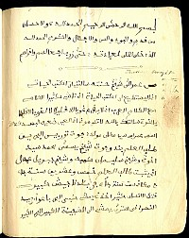

Comparing 18th-Century Futa Jallon to Antebellum Mississippi
When Abdul Rahman arrived in Natchez, Mississippi, in 1788, he had entered another world, a world very different from the world of Futa Jallon. Not only had his status changed from prince to slave, but he had entered a world with a new geography, economy, and culture. Find out more about life in the land of Abdul Rahman's birth and in the land of his enslavement.

What was 18th-century Futa Jallon like?
Futa Jallon is the mountainous heart of Guinea where six international rivers are born, including the Niger, the Senegal and the Gambia that sustain the lives of dozens of millions of people in West Africa. It is a lush region of grassland, trees, mountains, narrow valleys, and waterfalls, covering 30,000 square miles (a little less than South Carolina) and peaking at 5,000 feet. Futa Jallon is the territory of the pastoralist Fulbe (also called Fulani, Fulah, and Peuls) and the Jallonke farmers who gave their names to the region. Following the Jallonke, non-Muslim Fulbe herders from Senegal migrated to Futa in the 11th century, putting their cattle to graze in the highlands. Another wave of Fulbe migration followed in the 15th century; finally, in the 16th century, Muslim Fulbe from Mali made their way into the region.
In Abdul Rahman's time Futa Jallon was a thriving kingdom. Trade and religion closely connected it to the larger Muslim world, from North Africa to Mecca, where the most devout and valiant went on pilgrimage; and its economy was integrated into the Atlantic trading world. Futa Jallon remained a major independent power until the end of the nineteenth century when, after a failed attempt at expansion and unification, it succumbed to French conquest.
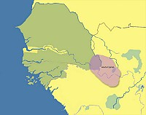

What was Antebellum Mississippi like?
We will focus on the city of Natchez, Mississippi. At the turn of the 19th century, Natchez, about forty miles upriver from New Orleans, was still a frontier town. It had begun as a settlement of the Natchez Indians on the bluffs overlooking the Mississippi River, with the Choctaw and Chickasaw Indians settled nearby. Over the course of time, Natchez was held by several countries: France, Britain, Spain, and finally the United States, which gained control of the area from Spain in 1798 - a decade after Abdul Rahman's arrival.
As of 1817, the population in the town was about 30% African or African-American; about half of the town's white residents had been born in other countries, particularly Britain and France. Much of the land remained in its natural state. As late as the mid-nineteenth century, more than half of the land around Natchez was uncultivated. Wildlife abounded: turkey, rabbit, raccoon, opossums, and more served as food for rich and poor alike. Housing in Natchez was generally modest, though by the 1820s, wealthy cotton planters had begun to build opulent mansions -- a trend which continued over the following decades as wealth increased from cotton production under the slave system. Click on the other pages of this module to learn about politics, slavery, economics, education, religion, and family in Futa Jallon (West Africa) and antebellum Mississippi.

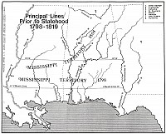

Comparing Politics

Futa Jallon Politics
In 1725, after a war led by Fulbe and Mandinka militant Muslims, Futa Jallon became a theocracy with a religious leader, the almamy (al-imam) Karamoko Alfa, at its head. The Islamic kingdom was very much defined by the transatlantic slave trade. It was born partly as a reaction to the insecurity and violence brought by the raids for captives. To counteract their terrible devastation, the Muslims formed a strong alliance to defeat the small Jallonke chiefdoms and build in their place a large, unified kingdom, secure and capable of protecting its inhabitants. Islamic Futa Jallon was organized into a confederation of nine provinces, each ruled by a religious leader. The political capital, built at the foot of a mountain, was Timbo.
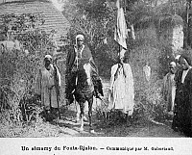

A city of about 9,000 in the early 1800s, it counted one mosque and three forts, one of which housed the almamy's palace. The rest of the population lived in round, thatched-roofed houses surrounded by gardens of banana, orange and papaya trees. "Timbo is the residence of the King and the army," wrote Gaspard Mollien a French traveler who visited in 1818. "I was informed, that as many as a thousand horses are to be seen there. The inhabitants are rich. All the women have silver bracelets and large gold ear-rings, and wear clothes of blue Guinea stuff, which is a sign of great luxury among these Africans", Mollien further noted. Futa also had a religious capital led by a council of elders, Fugumba. The towns were well fortified to protect the population from potential attacks.
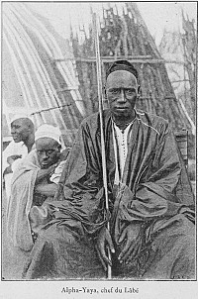

Natchez Politics
In 1798, when the United States gained control of the Mississippi Territory, it was a fledgling country, just two decades from its founding. In 1803 the new Mississippi state legislature made Natchez the first incorporated town in the territory and set up a local government made up of a mixture of leaders appointed by the state legislature and elected by the townspeople.
Members of the town's Common Council played many roles, governing the town, serving as justices of the peace, and providing a court to hear cases, both civil and criminal. Those in political power were primarily from the merchant class: Andrew Marschalk, the printer and editor involved in obtaining Abdul Rahman's eventual freedom, was on the council for several years. None of the leading landowners or slaveholders served in city government.
The town provided a wide variety of public services, including a fire brigade, jail, cemetery, public cistern, and hospital; the funds for most were raised by public lottery, license fees, fines, and property taxes. Only free white men were allowed to vote, excluding the majority of the area's populace. Until 1817, the requirements for voting also included either participating in the militia or having city real estate with property taxes paid, excluding even more of the denizens of the city.

Comparing Slavery

Slavery in Futa Jallon
Although they had strongly opposed the overseas slave trade, by the 1750s the leaders of Futa Jallon, including Abdul Rahman's father, engaged in it. They kept on protecting their own, but they raided non-Muslim populations over a vast area, retaining a number of captives and selling the rest to the Europeans. Futa society was mainly divided along religious lines -- Muslims and non-Muslim -- and ethnicity had little relevance. Non-Muslim Fulbe belonged to the lower classes and the enslaved community, whereas Muslim Mandinka, for example, were part of the elite. Only non-Muslims could be enslaved and the sale of Muslims was strictly prohibited. Prisoners of wars and raids bore the full brunt of servitude and their resistance could be fierce. Slave uprisings were recorded in the 1750s and the 1790s.
By the third generation, the status of a slave was similar to that of a freed person, and children born of a free father and an enslaved mother were free and could reach the highest echelon of political power. Some captives were blacksmiths, potters, weavers, and soldiers but most worked in agriculture and lived in villages in the countryside where they had little contact with their owners. Placed under the direction of one of their own, they grew rice, corn, grain, yam, peanuts, millet, and cassava. They worked in their fields and gardens two days a week to feed themselves, and could hold property. Part of the crops they produced for their owners was sold to the Europeans: it became the food distributed to the captives during the Middle Passage. As slavery expanded in the Americas, Futa Jallon's domestic slavery did as well because more and more captives were needed there to raise the crops and take care of the cattle, sheep, and goats sold to the growing European slave market on the coast.
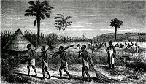

Slavery in Natchez

The system of slavery in the United States was a system of labor based on racial distinctions and permanent bondage, which made it different from other forms of slavery the world over. As Peter Kolchin explains, "The racial character of New World slavery was significant: that slavery was predicated on new, unequal relationships between Europe and Africa and between white and black." By 1830, more than 40% of the population of Natchez was enslaved, as was some 80% of the population in the surrounding county. Yet those enslaved persons were concentrated on a small number of large cotton plantations.
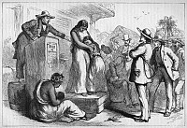
Throughout the South, fewer than one-fourth of white people held slaves, and nearly 90% of those who did owned fewer than 20 slaves. This was also true in Natchez and the surrounding region, where enslaved people made up a large percentage of the population, but were held by a small minority of wealthy planters. Nevertheless, even those white people who did not hold slaves were, in the main, fully in support of the slave system. Despite this, several hundred free African Americans continued to live in the community. By 1822, the Mississippi legislature had put in place mechanisms for making emancipation more difficult. People who were enslaved had varying experiences, though all lacked full control over their lives. Some worked in the fields. Others worked in the slaveholder's household. Some worked as craftspeople, carpenters, and blacksmiths.
While scholars have often portrayed those enslaved in the household as having an easier life, Anthony Kaye notes, "Working in the big house was more burden than privilege." Enslaved persons stationed in the household were under the constant watchful eye of the slaveholder and his family, which limited their autonomy and made less time available to them to manage their own personal affairs. For enslaved women, it also meant the ever-present possibility of sexual assault by the slaveholder. Those who worked in the fields faced daunting labor. For instance, men who plowed the fields averaged more than ten miles per day, and those chopping out old plants completed between four and seven miles of cotton rows each day! The relationship between slaveholder and enslaved person was characterized in great part by the slaveholder's underlying economic interest. As David Libby notes, "planters worked to establish a level of interaction between them and their slaves that would be harsh enough to ensure their superiority, but mild enough to avoid rebellion."
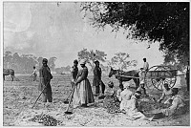
Insecurity and instability were the forces against which enslaved people organized their lives. Enslaved persons formed strong family bonds, in spite of their knowledge that the slaveholder or his descendants could tear families apart on a whim. In order to visit their family, enslaved persons violated laws requiring permission to travel from plantation to plantation, despite threats of vicious lashings. In short, enslaved persons found ways to "make a way out of no way," surviving despite the slaveholders' attempts to dehumanize them. Enslaved persons often sought to resist their enslavement, sometimes by running away, as Abdul Rahman did. Among those who absconded, more than 80% were men, and more than three-quarters were under thirty years of age. In 1850, the life expectancy for a twenty-year-old African American man was only 37!

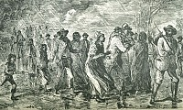

Comparing Economy

Futa Jallon's Economy With a multiethnic society of Jallonke, Susu, Mandinka, Fulani, Bassari, and Koniagui; with teachers, clerics, traders, free herders and farmers; and with captives brought from Senegal, Mali, and Guinea Bissau, Futa Jallon was a crossroads for various peoples who transited or settled there, voluntarily or not. It was a major producer of commodities. Matthew Winterbottom, who traveled through the kingdom in 1794, observed: "Their industry in agriculture and grazing is everywhere remarkable. They plant tobacco near their houses, and open tracts for cotton, which they fence in. They grow rice, maize, and the larger and lesser Guinea corn. The flour is not made into bread, but is used with milk, and in the composition of kous-kous." In addition, iron was mined in the mountains and gold in the rivers.
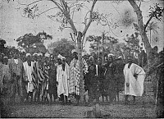
With its abundance of various products, Futa Jallon was the center of important trade routes. Walking to the Atlantic coast, caravans of merchants sold ivory, textile, beeswax, cattle, hides, gold and captives as far as Sierra Leone three hundred miles away. In the coastal urban centers, they bought iron, powder, firearms, salt, kola nuts, western cloth, paper, sugar and amber. This long-distance commerce could take two months and was sometimes dangerous: caravans were occasionally attacked, the goods stolen and the merchants and their captives sold to the European dealers. Traders also made a brisk business inland, north of Futa Jallon. They sold cattle, salt, kola nuts and captives and brought back horses, donkeys, and books.
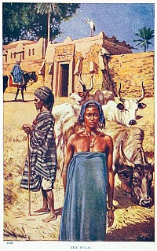

Natchez Economy
Natchez was a frontier town, without easy access to the outside world until the arrival of the steamboat around 1815. Until then, trade was difficult. Boat traffic was one way, downriver. Upriver trade required overland travel. While relatively small, Natchez was the largest town for hundreds of miles and eventually became a center of trade for the region. The invention of the cotton gin in 1794 provided an efficient method for removing the seeds from the short staple strain of cotton that grew best in the Mississippi Territory. By 1798, cotton had become the staple crop in the area. There had been brief, unsuccessful attempts to grow other crops, such as indigo -- which produces a rich blue dye valued by, among others, the Tuareg people of Mali, near Abdul Rahman's birthplace.
In addition to serving as a commercial center, the Natchez region was deeply tied to the growing cycle of cotton. In the spring, women and children beat down the old cotton plants, with men then plowing the fields. In April, women sowed the seeds. Then, both men and women weeded and thinned the fields. The cotton harvest began in September and ran through October. During the seasonal down times, men and women were involved in tending other crops, both for the slaveholder and for their own households. They also worked on neighboring plantations or repaired roads in the area. Some people were able to earn money from their own work on the side, as Abdul Rahman did by selling produce at the local market.
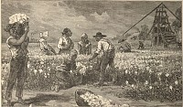

Comparing Education

Education in Futa Jallon
The military and religious aristocracy and the notables had the time and the means to devote themselves to study and religious affairs, and Futa Jallon became a renowned center of education. Qur'anic schools functioned in almost every town and by the end of the 19th century, the kingdom counted as many as 3,000. Students learned to read, write, and recite the Qur'an, and some pursued higher education locally or in Timbuktu, Senegal, or North Africa. Females were educated too. Lamine Kebe, a former Qur'anic teacher from Futa enslaved in the United States, stated that a number of girls frequented his school. He was proud of the fact that his aunt was more learned than he was and that she was a skilled teacher. He also knew "women who have been devoted teachers for life, and have rivaled some of the most celebrated of the other sex in success and reputation for talent and extraordinary acquisitions."
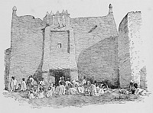
As early as the 18th century, the Qur'an was translated into Pular, the language of the Fulbe, and as the Holy Book became more accessible, Islam grew deeper roots. Books on a variety of topics, religious and secular, were imported from North Africa and produced locally in Pular written in the Arabic script.

Education in Natchez
In 1800, there were no schools of any sort in the Natchez area. The wealthy often hired tutors, though often with lackluster results. As the years went by, a number of small private academies opened for both boys and girls. However, there was little demand; and the schools, generally owned and operated by a single teacher, soon closed. As a result, there were high levels of illiteracy across the population. This began to change in the 1840s, as schools like the Natchez Institute opened. It had more than 600 students in 1853.
For African Americans, however, the situation was even worse. In Africa, Abdul Rahman had received a rich childhood education. In contrast, enslaved persons in the early United States were excluded from the formal educational system. By 1860, only five percent of the African American population in the United States could read. Many states, including Mississippi, had laws making it difficult for enslaved persons to become literate. The 1822 Mississippi slave code, for instance, made teaching an enslaved person to read punishable by one year's imprisonment. Nevertheless, some enslaved people were indeed literate, either because they arrived already educated, as in the case of Abdul Rahman, or because they were taught by a fellow African or (on rare occasions) a slaveholder.

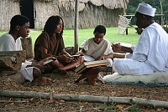

Comparing 18th-Century Futa Jallon to Antebellum Mississippi - Digging Deeper
Would you like to learn more about this topic? Here are some suggestions for digging deeper:

Futa Jallon
Boubacar Barry, Senegambia and the Atlantic Slave Trade. Cambridge: Cambridge University Press, 1998.
Philip D. Curtin, Economic Change in Precolonial Africa: Senegambia in the Era of the Slave Trade. Madison: University of Wisconsin Press, 1975.
John O. Hunwick and Alida Jay Boye, The Hidden Treasures of Timbuktu: Rediscovering Africa's Literary Culture. London: Thames and Hudson, 2008.
Martin A. Klein, Slavery and Colonial Rule in French West Africa. Cambridge University Press, 1998.
Tierno Monénembo, The King of Kahel, translated by Nicholas Elliott. AmazonCrossing, 2010.
Marq de Villiers and Sheila Hirtle, Timbuktu: The Sahara's Fabled City of Gold. New York: Walker & Company, 2007.
Natchez
Davis, William C. A Way through the Wilderness: The Natchez Trace and the Civilization of the Southern Frontier. New York: HarperCollins, 1995.
Kaye, Anthony E. Joining Places: Slave Neighborhoods in the Old South Chapel Hill: University of North Carolina Press, 2007.
Kolchin, Peter. American Slavery, 1619-1877. New York: Hill and Wang, 1993.
Libby, David J. Slavery and Frontier Mississippi, 1720-1835. Jackson: University of Mississippi Press, 2004.

African Muslims Enslaved in the United States and Elsewhere
Between the seventeenth and the mid-nineteenth century, numerous West African Muslims mostly from Senegambia (Senegal, Gambia, Mali, and Guinea) were deported to the United States. They were overwhelmingly young men, most often prisoners of war but also victims of kidnapping. It is difficult to estimate their numbers among the close to 400,000 people who survived the Middle Passage to the United States. But nowhere else in the Americas was the proportion of Senegambians -- 24% -- as high as in this country. Senegambia was the area of West Africa that had been Islamized the longest, beginning as early as 1010.
If most Muslims maintained their faith in secret in the barbaric environment of servitude, others succeeded in living their religion openly. Reports of their religious activities appear in court and police records, plantation logs, newspapers, books, and runaway notices. Their portraits were captured in paintings, prints, daguerreotypes, and photographs; and they have left a few manuscripts written in Arabic.
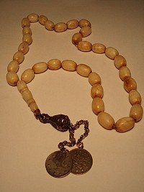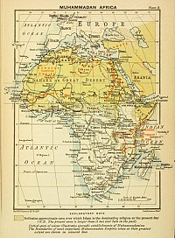

Literacy Among Enslaved Muslims
As a rule, slave societies in the Americas forbade -- either legally or through intimidation -- the people they kept in bondage from learning to read and write because of the subversive nature of literacy. But there was nothing they could do against the African Muslims' knowledge because they arrived with it. Actually, literacy was sometimes at the origin of some people's deportation to America. Qur'anic teacher Lamine Kebe of Timbo in Futa Jallon was seized while he was on a trip to buy paper for his students, and he spent the next thirty years enslaved in the American South. Another teacher, Ayuba Sulayman Diallo (known in the West as Job ben Solomon), a father of four from Senegal, was kidnapped at a British post by the Gambia River, where he had gone to buy paper and sell captives.
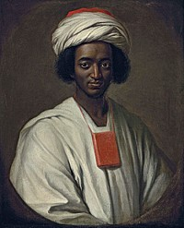
On the other side of the ocean, although engaged for life in manual labor, some African Muslims still considered themselves scholars and maintained their identity as Muslims and intellectuals through the written word. Perhaps the most moving attempt at communication through writing was done by Omar ibn Said, a teacher and trader from Senegal who landed in Charleston, South Carolina in late1807. About a month after he had run away from his owner's rice plantation, he was captured and thrown in jail in North Carolina. Unable to communicate in English, he tried to do it in the only other way he could think of. With some coals he had found in his cell, he filled the walls with petitions to be released, written in Arabic. As a literate man, his first reflex had been to express himself through writing. Omar wrote his autobiography in Arabic in 1831.
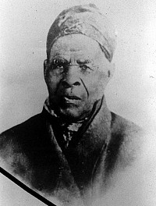
Bilali Mohammed from Timbo, enslaved on Sapelo Island in Georgia with his wife and daughters, left a 13-page religious document in Arabic. It is part of a 10th century treatise on jurisprudence. Ibrahima Abdul Rahman wrote a letter in Arabic that was sent to the sultan of Morocco, and several copies of al-Fatiha (the first chaper of the Qur'an) to raise money to buy his children's freedom. Job ben Solomon, at fifteen, "could say the whole Alcoran by heart, and while he was here in England he wrote three Copies of it without the Assistance of any other Copy, and without so much as looking to one of those three when he wrote the others." Three years after he had arrived in Maryland, he was freed, thanks to a letter in Arabic he had written to his father in Senegal asking to be redeemed, and he returned to Senegal in 1734.

Islamic Dress

Religious identity was also preserved in the dress some men and women managed to keep. Job ben Solomon's portrait, realized in London in 1733, shows him posing in a white turban and a white robe. What he was really wearing were Western clothes, but he had insisted on being represented "in his own country dress" which he described to the artist. Bilali, the patriarch of Sapelo Island, was said to always wear a cap that resembled a Turkish fez. Portraits of Omar ibn Said show him with a skullcap and buttoned up jacket; he sometimes sported a white turban. The centenarian Yarrow Mamout of Maryland, who had bought his freedom back and who prayed in the street, is immortalized in an 1819 painting very well covered in coat and hat. And, as their grandchildren recounted in the 1930s, some Muslim women enslaved in the Georgia Sea Islands wore white veils.
By rejecting the crude, degrading garments handed to them and by wearing the clothes that had signaled that they were Muslims in Africa, some of the men and women who labored on the American plantations were affirming their cultural, personal and religious identity and integrity. They were reclaiming possession of themselves and their bodies, which was a rebellious act in slavery since those bodies were paid for and legally belonged to the slaveholders.
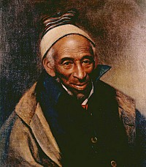

Muslim Women and Charity
Muslim women were few, about 24 percent of the total number of Senegambian captives, but in one place where many were concentrated, they made a lasting impression. On the Sea Islands, a song sung by children well into the twentieth century has kept their memory alive. It goes thus: "Rice cake, rice cake - Sweet me so - Rice cake sweet me to my heart." Everyone on the island called these rice cakes saraka and people assumed it meant rice cake in an African language. But the word actually comes from the Arabic sadaqa (changed into saraka, sarakh, or saraa in Africa) or freewill offerings and refers to a custom derived directly from West Africa where Muslim women offer rice balls to the children on Fridays as a charity, a sadaqa. In Georgia, the women were not calling the cake saraka, they were saying, as they handed them out, it was a saraka (an offering) in the name of God. Their almsgiving was true to the authentic spirit of sadaqa since tradition states that the best sadaqa is the one given by a person who owns little.

The Legacy of Enslaved Muslims
What the lives and struggles of most Muslims were like as they confronted the dreadful reality of enslavement remains unknown, but the successes of a number of them in remaining true to their faith and its rites has been documented. Some fasted during Ramadan, abstained from liquor and pork, gave Muslim names to their children, prayed as many times a day as they could, and had prayer mats and prayer beads. Despite their efforts, West African Muslims in general were not able to pass on their religion to the next generations. Few men could find Muslim spouses, a factor that played a significant role in the demise of the religion, since enslaved children were often cut off from their fathers through sale or residence on other plantations. When close-knit Muslim families existed, as was the case on the Sea Islands, it is often in the third generation that Islam disappeared, especially when churches started to proselytize massively after emancipation in 1865.
Still, the West African Muslims have left an inspiring legacy: dignity, pride in themselves and their culture, strong will, strong faith, a thirst for knowledge, and religious and intellectual pursuit even in the most repressive environment.

Enslaved Muslims - Digging Deeper
Would you like to learn more about this topic? Here are some suggestions for digging deeper:

Books
Alford, Terry. Prince Among Slaves: The True Story of An African Prince Sold Into Slavery in the American South. New York: Oxford University Press, 1986.
Austin, Allan D. African Muslims in Antebellum America: Transatlantic Stories and Spiritual Struggles. New York: Routledge, 1997.
Crook, Ray. "Bilali-The Old Man of Sapelo Island: Between Africa and Georgia," Wadabagei, 10, 2, (Spring/Summer 2007): 40-56.
Diouf, Sylviane A. Servants of Allah: African Muslims Enslaved in the Americas. New York: New York University Press, 1998.
Gomez, Michael A. Black Crescent: The Experience and Legacy of African Muslims in the Americas. Cambridge: Cambridge University Press, 2005.
Martin, B. G. "Sapelo Island's Arabic Document: The 'Bilali Diary' in Context." Georgia Historical Quarterly 78, 3 (Fall 1994): 589-601.

Online Resources
Literacy in West Africa
Slavery and Manumission Manuscripts of Timbuktu
Mamma Haidara Library
Manuscripts from the Mamma Haidara Library, Timbuktu
Islamic Manuscripts from Mali
Autobiographies, Biographies, Biographical Sketches
Biography of Job ben Solomon
Autobiography of Omar ibn Said and other documents
The Life of Omar ibn Said. Aramco article by Jonathan Curiel
Entry about Omar ibn Said in Davidson Encyclopedia
A Statement with Regard to the Moorish Prince, Abduhl Rahhahman
From African Prince to Mississippi Slave: Abdul Rahman Ibrahima Podcast
Autobiography of Nicholas Said
Biography of Mahommah G. Baquaqua
Bilali, the Old Man of Sapelo
General Articles
Islam and the Gullah/Geechee Community, Georgia Historical Society
Diversity in the 'Christian Nation': Muslim Slave's Story Inspires Commentary on Tolerance NPR
Saving the soul of a culture Gullah-Geechee way of life teeters on extinction, Atlanta Journal Constitution
Mainstream Islam in the African-American Experience Richard Brent Turner
A Language Explorer Who Heard Echoes of Africa The New York Times.

Luminaries
As if written in the stars themselves, Abdul Rahman's path crossed that of numerous luminaries of nineteenth-century North America, as the prince and former slave sought the aid of these leaders of the young country that held, but had not yet fulfilled, the promise of freedom for all. Forty years of enslavement and hard labor from sunup to sundown on a steamy Mississippi plantation could not dim the noble spirit of African prince Abdul Rahman, who never wavered in his belief that freedom, not bondage, was his rightful destiny.
In 1828, with the help of friends in Natchez and the intervention of the U.S. government, plantation owner Thomas Foster was persuaded to release the prince from slavery, and Abdul Rahman finally got his freedom. It was not an unconditional release: Foster's one requirement -- that the prince return immediately to his African home -- was one condition Abdul Rahman could not keep. Bravely defying the dictate of his former owner, the prince instead embarked on a tour of the northern states, telling his story before huge audiences and seeking support in his efforts to reclaim his family. In his heart he carried the image of his children, still bound in bitter slavery in Natchez; in his pocket, he carried his subscription book, soliciting money to buy their freedom.
Abdul Rahman's tour of the North made him the most famous African in America and a flashpoint of controversy in the increasingly ugly 1828 presidential campaign. Throughout the tour, Abdul Rahman encountered millionaires, governors, congressmen, ministers, abolitionists, even a president -- the leading men of the day. In all these meetings, Abdul Rahman treated the men as peers and equals, acting always with the dignity of a prince. In turn, his own nobility of spirit was recognized by many of those he met.
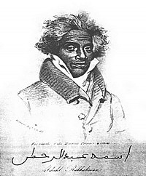
Vimeo link: https://vimeo.com/20841891

Meet the Luminaries

President John Quincy Adams
As President of the United States, it was John Quincy Adams who directed the government to seek Abdul Rahman's freedom. But the meeting between the president and the prince, following the granting of that freedom, did not end the way either man had hoped. As the son of John Adams, one of the founding fathers and the second president of the United States, John Quincy Adams had quite a legacy to live up to. He distinguished himself early in politics and diplomacy. As secretary of state under President James Monroe, Adams helped cement vital trade ties for the young nation, and masterminded the Monroe Doctrine. Adams' term as president was not as popular and he had reason to be concerned for his political future.
After the prince arrived in Washington, he met with Adams twice. The first meeting was a success, as the two men talked not as a wealthy aristocrat and poor ex-slave, but as peers and equals. The second meeting, unfortunately, was tinged with political considerations. Abdul Rahman asked Adams to donate money to free his enslaved children. The president, already realizing that freeing the slave would end up hurting him in the upcoming election, flatly refused. But aside from political expediency, Abdul Rahman, it turns out, was also a victim of bad timing. According to his diary, Adams was sick and already having a miserable day as unwelcome guest after unwelcome guest came to the White House to ask for his help. If the prince had come on a different day, when Adams was in robust good health and enjoying pleasant visitors, might his reaction to Abdul Rahman's request been different?
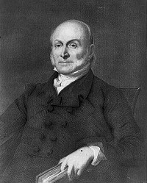
In any case, after a bitter campaign in 1828, Adams lost the presidency to Andrew Jackson. Later in life, Adams was elected to Congress, where he became the government's leading opponent to slavery and, along with Arthur Tappan and others, helped organize the successful defense of the Africans who revolted on the slave ship Amistad. Perhaps his experiences with the slave prince Abdul Rahman helped set the stage for this later less equivocal commitment to justice.

https://vimeo.com/20841116

To read John Quincy Adams' State of the Union Addresses, click here

Henry Clay
Known as "The Great Compromiser," Secretary of State Henry Clay never compromised his principles when it came to defending the Union. As a congressman, senator, speaker of the house, and secretary of state, Clay was at the center of every crisis in the U.S. government, wheeling and dealing in desperate attempts to stave off the Civil War. He was also at the center of the saga surrounding the prince and proved to be a key figure in his last year in America. Though Clay was a Southern man of the times and owned slaves himself in Kentucky, he abhorred the institution, calling it "the deepest stain on the character of the country," and favored gradual emancipation.
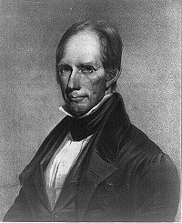
As a founding member of the American Colonization Society, he was glad to help Abdul Rahman regain his freedom and repatriate him to Africa. It was Clay who wrote the original letter telling Foster that the government wanted to free Abdul Rahman, and when that was achieved, it was Clay who provided the prince with a passport that allowed him to travel throughout the Northern states more easily. Clay met with Abdul Rahman twice in those last months, first in Baltimore and then in Washington, D.C., where he even offered to let the prince stay in his own house. Abdul Rahman declined, but an observer at the time noted that "he is highly delighted with Mr. Clay."
Though powerful in Washington, Clay never gained widespread national support due to his views on slavery and a centralized government. He sought the presidency five times, but never won it. When told by advisors to tone down his unpopular views, Clay simply replied, "I'd rather be right than be president." Clay was never president, but he was surely right when it came to slavery and to Abdul Rahman's quest for freedom. Clay continued to serve his country until his death, when he became the first person ever to lie in state at the U.S. Capitol Building. But perhaps the loyalty of this politician to the principles of equality and freedom, which so delighted Abdul Rahman, is the greater legacy.
New Orleans:
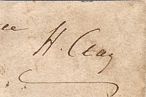
Henry Clay's Signature
President John Quincy Adams' State of the Union Addresses
Audio File: Henry Clay can not be played.

Nathaniel Ware As Abdul Rahman boarded the steamship Neptune in April 1828 and watched Natchez fade into the distance for the last time, it was surely a bittersweet parting. His own freedom in hand, Abdul Rahman carried with him the heavy knowledge that his children's tether had not been cut. He was accompanied on his journey by one of Foster's wealthy planter friends, Nathaniel A. Ware. One of the luminaries of the colonial South, Nathaniel A. Ware was an attorney, wealthy land speculator, public official in Natchez, and one-time acting governor of Mississippi. As the father of poets Catherine Ann Warfield and Eleanor Percy Lee, he headed what was to become a Southern literary dynasty.
Known as the "Two Sisters of the West," the daughters were the first wave of writers connected to the Percy family, which would soon become famous for its literary contributions throughout the antebellum South. Among its later members was the famous novelist Sarah Dorsey, who was possibly the mistress of Confederate President Jefferson Davis. But as Ware accompanied the freed slave on his journey from the land of his servitude in 1828, the Confederacy, secession, and the unstoppable tide of abolition had not yet appeared on history's stage. On this day, Ware was an official of the status quo who stayed by Abdul Rahman's side until the two arrived in Washington, D.C.
Here in the seat of the government that had helped secure his release, the prince parted company with Ware, who went on to Philadelphia. Months later, as Abdul Rahman passed through Philadelphia on his northern tour, the two met again. Perhaps it was the time Ware spent in the city where the Declaration of Independence, proclaiming the equality of all men, had been heralded by the Liberty Bell, or perhaps it was the time he spent with Abdul Rahman, but Ware stepped outside his expected role. A slave owner himself, he donated $10 (which in those days was real money) to the fund to free Abdul Rahman's children.
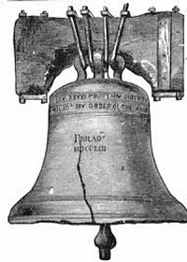

Benjamin Lundy
One of Abdul Rahman's first stops on his journey to the U.S. capital was the seaport of Baltimore, where he hoped to meet with Benjamin Lundy, publisher of the anti-slavery newspaper Genius of Universal Emancipation. A Quaker and founder of several anti-slavery magazines, Lundy was one of the leading abolitionists of the early nineteenth century. A meeting with him had been suggested by Colonel Marschalk, the Mississippi journalist who was an early champion, and later detractor, of Abdul Rahman. In fact, Lundy had even already printed stories about Abdul Rahman, and his help in telling the plight of the prince's children would be valuable, as he was a man whose reach went far and wide.

Renowned abolitionist William Lloyd Garrison later became co-editor of the Genius of Universal Emancipation before moving to New England to found The Liberator. Lundy's own anti-slavery efforts took him across the United States, where he preached emphatically against the evils of slavery, risking imprisonment and physical attacks from slave traders. Indeed, he was away on this business when Abdul Rahman came to Baltimore. He had also traveled to Haiti and later visited Canada and parts of what was then Mexico to find a suitable site to establish a colony for people who had been enslaved.
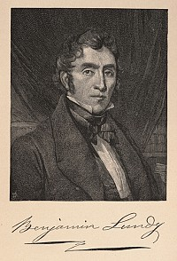
Despite Lundy's absence, the prince's story nonetheless reached the people of Baltimore. In the May 10 issue, Lundy's assistant William Swaim published a heartfelt plea to the citizens of Baltimore: "Though this victim of ruthless misfortune has lately stepped into the enjoyment of his natural rights, he has children remaining at Natchez. While he related to us this painful truth, the tears gushed from his eyes and rolled down his cheeks!"
Following Benjamin Lundy's death, an 1839 editorial in Garrison's The Liberator explained that Lundy knew "how essential to the awakening of a lethargic nation was a regular anti-slavery periodical. It was for Lundy to place a just and sagacious estimate upon the all-shaking power of the press."
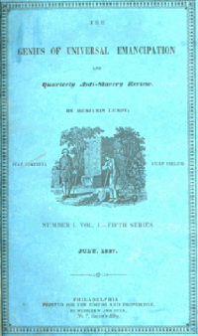

Thomas Gallaudet

Reverend Thomas Gallaudet himself sought a meeting with Abdul Rahman, rather than the other way around. Gallaudet first contacted Abdul Rahman after reading some of the prince's remarks about Christianity in the newspaper. After meeting him, Gallaudet became one of Abdul Rahman's most loyal supporters. Not only was he moved by Abdul Rahman's quest to free his children, but he also saw in the prince a surefire method of spreading Christianity to Africa. Abdul Rahman had no intention of converting to Christianity but pretended to be open to the idea to insure Gallaudet's help. The pastor joined Abdul Rahman on parts of the northern tour, appealing eloquently to congregations to raise money.

Gallaudet was an energetic preacher who from an early age wanted to devote his life to helping others. In early October, he had significant success doing just that: His heartfelt homilies netted Abdul Rahman over $150 from churchgoers. At various times, Gallaudet wanted to be a lawyer, a missionary, and an author of children's books. He found his true calling when he met Alice Cogswell, the deaf daughter of his neighbor, and devoted his life to the education of the deaf in America. In 1817, he founded the Hartford School for the Deaf, the first institution of its kind in America.
Though Gallaudet also spent his energies on other causes, such as the American Colonization Society and the exporting of Christianity overseas, it is his pioneering work in the education of the deaf for which he is remembered. This cause remains alive today because of the interest he instilled in his son, Edward, who founded the first college of the deaf, Gallaudet University, in Washington, D.C., in 1857.
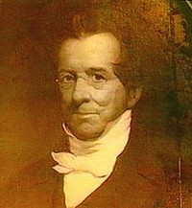
Thomas Gallaudet

John Brown Russwurm

In New York City, Abdul Rahman became a good friend of John Russwurm, who since 1827 had been editor of Freedom's Journal, the first newspaper in America printed, edited and owned by African Americans. The son of a white Jamaican merchant and an unknown black mother, John Brown Russwurm was at the forefront of many things: He attended Maine's Bowdoin College, where he was a classmate and friend of Nathaniel Hawthorne and was also chosen to present the commencement address in 1826; the following year he became the third African American to graduate from college in the United States.
Although initially an opponent of the American Colonization Society, arguing that it was a strategy to remove free blacks from the United States and thus solidify the institution of slavery, Russwurm nonetheless befriended Abdul Rahman and was profoundly influenced by him. Indeed, after meeting the prince, Russwurm himself began to consider immigrating to Liberia. He described the change in his thinking in an article in Freedom's Journal in March 1829: "In the bosom of the most enlightened community on the globe, we are ignorant and degraded; under the most republican government, we are denied all the rights and privileges of citizens; and what is still worse, we see no probability, that we as a community will ever make it . . . to rise from our ignorance and degradation. . . . We consider it mere waste of words to talk of ever enjoying citizenship in this country." (cited in Young, 108, from 3/23/1829)
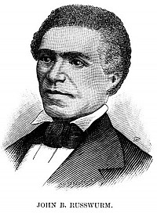
When Abdul Rahman left the city, Russwurm wrote a bittersweet farewell in Freedom's Journal: "Abdul Rahman came among us as a stranger, but he departs from our city with the well wishes of thousands. "New York was not to be Russworm's city much longer: He was soon to follow in the footsteps of his new friend, crossing back over the same ocean that had brought his ancestors to slavery. Having changed his stance on the American Colonization Society, much to the chagrin of other African American activists of the time, Russworm emigrated to Liberia in 1829, where he served as colonial secretary for the ACS and eventually as governor of the Maryland Section of the colony.

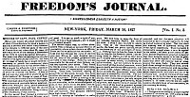
For further information:
The Russwurm African American Center at Bowdoin College
Russwurm's Commencement Address, Bowdoin College, 1826
Sandra Sandiford Young, "John Brown Russwurm's Dilemma: Citizenship or Emigration?" In Prophets of Protest: Reconsidering the History of American Abolitionism, ed. Timothy Patrick McCarthy and John Stauffer, 90-113 (New York: New Press, 2006).
Winston James, The Struggles of John Brown Russwurm: The Life and Writings of a Pan-Africanist Pioneer, 1799-1851 (New York: NYU Press, 2010).

Edward Everett
Among the many officials Abdul Rahman met and made a lasting impression on during his northern tour was a young congressman named Edward Everett, who was so moved by the prince's story that he donated $5.00 to Abdul Rahman's subscription book to free his children. Everett was still touched by the meeting decades later. In 1853, he recalled in a speech that Abdul Rahman "had the port and air of a prince, and the literary culture of a scholar."
Perhaps Everett simply recognized Abdul Rahman as a kindred spirit, who, under other circumstances, might have been his colleague, rather than someone who needed his help. Considered the greatest American orator of his time, Edward Everett was one of the most respected and distinguished men in the country, both in politics and education. The first American to receive a Ph.D., Everett was a professor and later president of Harvard University. In politics, he served as a congressman, senator, governor of Massachusetts, and secretary of state.
In the battle for the heart of the young nation that would take place nearly a quarter of a century after Abdul Rahman's northern tour, Everett remained on the right side of history. The most memorable moment of Everett's career came in 1863 when he was invited to speak at Gettysburg. Unfortunately, the concept that "less is more" was lost on Everett, and the dense, two-hour sermon he delivered before President Lincoln's remarks quickly became a historical footnote in the shadow of Lincoln's much briefer and more eloquent words. Schoolchildren everywhere learn of Lincoln's Gettysburg Address, but the same can't be said for Everett's remarks. This was not lost on Everett himself, who would later write a note to President Lincoln admitting, "I should be glad, if I could flatter myself that I came as near the central idea of the occasion in two hours, as you did in two minutes."
To read Everett's Gettysburg Oration, click here
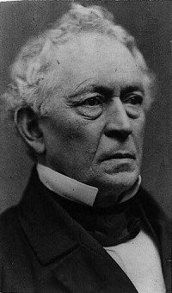

David Walker
By the time Abdul Rahman arrived in Boston, his hopes of freeing his children were beginning to fade. Public interest in his story had begun to wane, and as word of his travels reached the South, it became clear that the prince was making just as many enemies as friends. In Boston, however, the city's black population gave Abdul Rahman a hero's welcome. At the extravagant banquet held in his honor at the city's African Masonic Hall, one of the marshals was the passionate activist, David Walker. A string of toasts, many led by Walker, were made in honor of Abdul Rahman during an evening that must have bolstered the prince's spirits as he prepared himself to make the long journey home without the freedom of his children having been achieved.
Though he was a simple owner of a clothing store, David Walker became one of the most inflammatory and controversial abolitionists in U.S. history. Within months of Abdul Rahman's visit to Boston, Walker published Walker's Appeal, a pamphlet in which he argued for the emancipation of the slaves and condoned violence as a way of achieving that goal. In the Appeal, Walker argues that the situation of enslaved people in the United States is more "wretched" than that of other forms of slavery, and that God is on the side of justice.
"Remember Americans, that we must and shall be free and enlightened as you are, will you wait until we shall, under God, obtain our liberty by the crushing arm of power? Will it not be dreadful for you? I speak Americans for your good. We must and shall be free I say, in spite of you. You may do your best to keep us in wretchedness and misery, to enrich you and your children; but God will deliver us from under you. And wo, wo, will be to you if we have to obtain our freedom by fighting."
The pamphlet spread throughout the country like wildfire, and caused debate and controversy wherever it was read. Cities in the South were terrified by the Appeal and tried to suppress its circulation. Many free blacks in the South were arrested for even owning the pamphlet, and plantation owners offered a $3,000 reward to anyone who would kill its author. In 1830, Walker was mysteriously found dead outside his home; city officials claimed that Walker died of tuberculosis, but the cause of his death remains a topic of debate to this day. By then, Prince Abdul Rahman was also gone, having returned to Africa only to die shortly before reaching his home and reclaiming the destiny denied him for the better part of his life.
To read Walker's Appeal in its entirety, click here
For further information:
Peter Hinks, To Awaken My Afflicted Brethren: David Walker and the Problem of Antebellum Slave Resistance (Pennsylvania State University Press, 1996).
David Walker, David Walker's Appeal: To the Coloured Citizens of the World (Pennsylvania State University Press, 2000).
Walker's Appeal

Francis Scott Key
As a member of the American Colonization Society's board of managers, lawyer and poet Francis Scott Key had the opportunity to hear firsthand about the horrors of the slave trade from Abdul Rahman. In a special and unusually well-attended meeting of the board, Abdul Rahman, Key and other ACS members discussed the possibility of purchasing the freedom of the prince's children still enslaved on Foster's plantation. This the Society was unable to do, though it did help pay for Abdul Rahman's fundraising travels through the North and his eventual return to Africa.
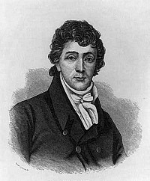
Famous for writing "The Star Spangled Banner," Francis Scott Key was only an amateur poet and was better known at the time as a high-profile lawyer, taking on some of the larger cases of the early nineteenth century -- he successfully defended Sam Houston after the "Father of Texas" got in a fistfight with a congressman, and he was chosen to prosecute Richard Lawrence, who had tried to assassinate President Andrew Jackson in 1832.
Key's immortal ode to the United States flag was inspired as he watched the British bombard a fort in Baltimore Harbor. The poem, "The Defense of Fort McHenry," was eventually combined with an old English drinking song, and it became the U.S. national anthem in 1916. Although Key's phrase "land of the free" would not encompass all U.S. citizens for many years, Key's small part in Abdul Rahman's fight for the freedom of his children was a step in that direction. Though he never considered himself a songwriter, Key was elected to the Songwriters' Hall of Fame in 1970.

Samuel Southard The portly secretary of the Navy, Samuel L. Southard, whom Abdul Rahman met during his Washington visit, seemed fated to become part of the prince's story. Though their meeting was brief, Southard would play a major role in Abdul Rahman's journey away from slavery. As secretary of the Navy, Southard had extensive ties in Africa and with the American Colonization Society. These were vital connections as Southard organized Abdul Rahman's ocean voyage to Liberia, from which he was to travel overland to his home.

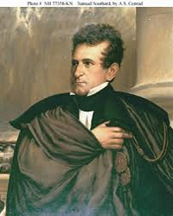

Southard was a career politician, serving as a senator, governor of New Jersey, and acting vice president under John Tyler, but his lasting legacy is as one of the most important leaders in early American maritime history. He vitalized the young Navy, building the first naval dry docks and hospitals, improving administration, and promoting U.S. exploration as far as the Pacific Ocean -- this in a time before the Panama Canal. The destroyer USS Southard, which fought its way through the worst sea battles in World War II, carried his name and legacy as a naval leader into the next century. But Southard should also be remembered as the man who helped reverse the cruel Middle Passage, which took Prince Abdul Rahman away from his own destiny as a leader in Africa.

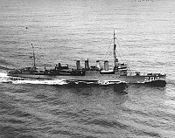

Joseph Jenkins Roberts

On board the Harriet, Joseph Jenkins Roberts was, like Abdul Rahman, traveling to Liberia. As a twenty-year-old free black man, born in Virginia, he was emigrating to an Africa that he had never known but that promised a new life, free of the codes that restricted the day-to-day activities of black people in the United States.
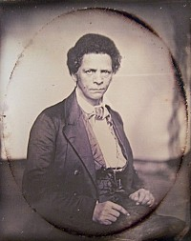

Born in 1809, he grew up working on a flatboat with his stepfather. In addition, he served as an apprentice in a barbershop; the African American owner of the shop allowed Roberts access to his library and, through the books there, to explore a new world of knowledge. He and his extended family wanted to emigrate to Liberia for the same reason as many other emigrants: they wanted to escape the grinding experience of racism and repression of life in Virginia.
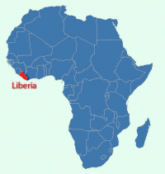

In Liberia, Roberts engaged in a trade partnership with the barber to whom he had apprenticed in the United States, exporting goods from Liberia to the U.S. He was appointed vice governor of Liberia by the American Colonization Society, then later the first African American governor of the country. Upon Liberia's independence in 1847, Roberts was elected the country's first president, serving for six years, then later also served as its seventh president. Between presidencies he taught and served as president of the newly founded Liberia College.

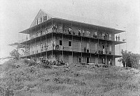

Arthur Tappan Arthur Tappan was among the participants in the first meeting Abdul Rahman had upon his arrival in New York City. He and his brother Lewis, wealthy businessmen, were active abolitionists and later key financial backers of the American Antislavery Society, which they helped found in 1833.
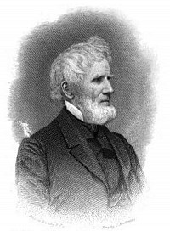

Tappan also provided support to Prudence Crandall, a Connecticut abolitionist jailed after opening a school for African American girls. Both Arthur and Lewis were evangelical Christians, spurred in their antislavery efforts by a deeply-rooted faith. In his autobiography of Arthur, Lewis explained that Arthur believed "all men" were to be seen "without distinction of complexion or condition." Certainly, they were impressed by Abdul Rahman, of whom Lewis wrote, "Abdual Rahaman was . . . well educated, tall and dignified in appearance, and read the Arabic language fluently and wrote it with elegance. His princely bearing and intelligence excited much interest."
Over the course of Abdul Rahman's time in New York, he and Tappan spoke at great length about religion and more, including the possibility of building a partnership to build trade connections to the interior of Africa. Tappan was deeply invested in Abdul Rahman, purchasing a house frame to be transported with Abdul Rahman to Liberia and then later, after Abdul Rahman's death, endeavoring, though unsuccessfully, to purchase his children's freedom.

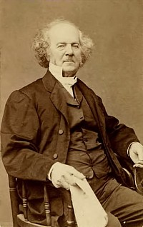

Prudence Crandall
In 1833, Prudence Crandall opened a school in eastern Connecticut "for the reception of young ladies and little misses of color." This event sent a shock wave through Connecticut society and brought abolitionism center stage. Crandall, a Quaker, had, at the invitation of town leaders, originally opened a school for local white girls in 1831. In 1833, Sarah Harris, an African American girl, asked to attend the school and Crandall, having read copies of William Lloyd Garrison's Liberator given to her by one of her employees, agreed. She explained, "My feelings began to awaken . . . [I] saw the prejudice of whites against color was deep and inveterate."
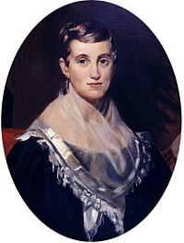

Immediately, there was a strong community backlash against Crandall. The white students were pulled out of the school by their parents, yet Crandall refused to yield to their demands, and the school was eventually closed. She reopened the school in 1833, specifically for young black women, again to strong community reaction -- local stores would not do business with her, the local doctor refused to treat the students, and neighbors threw rocks and eggs at the building. One local opponent explained, "The colored people can never rise from their menial condition in our country, they ought not be permitted to rise here."
In response to Crandall's school, the state legislature passed the "Black Law," which forbade out-of-state students of color from attending schools in Connecticut without the permission of the local community. Crandall was arrested in 1833 and stood trial; the school was closed in 1834. Arthur Tappan, a leading New York abolitionist, paid for Crandall's defense. Crandall's courage stood as a testament to many women of the time, fostering an emerging political consciousness.
To learn more about Prudence Crandall, click here
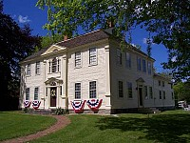

Islam and the Blues
For more than a century the blues, born in the Deep South, has conjured up images of cotton fields, oppressed sharecroppers, pain, lonesomeness and misery. When one thinks about a music so embedded into rural African-American culture, Islam does not come to mind. Yet it should, because the deepest roots of the blues grew not in the Mississippi Delta but thousands of miles away.
It all started in the savannas of the Sahel, the 1000-mile wide savannah belt just south of the Sahara desert that stretches from the Atlantic coast in the west to the Red Sea in the east. In the Sahel, people from Senegal, Gambia, Guinea, Mali, and neighboring countries created, out of various influences, a musical style that eventually traveled west with the transatlantic slave trade and transformed itself on the American plantations.
As early as the 8th century, Sahelian West Africans came into contact with Muslim Arab and Berber traders from North Africa. By the dawn of the 11th century, many had converted to Islam, which had spread peacefully, not through wars or conquests. The sub-Saharan Muslims traded with the North Africans, traveled to Morocco, Egypt, Algeria, and as far as Arabia, 3,800 miles away, to make the pilgrimage to Mecca. Among the cultural exchanges that took place between North Africa and the Middle East on the one hand and the Sahel on the other were music and a singing style of a particular kind. The characteristics of the Islamic type of singing that Sahelians adopted are found, primarily, in the recitation of the Qur'an and the call to prayer. The individual, male or female, who recites the Qur'an uses wavy intonations, strong trembling sounds, vibrato, and long pauses between sentences; they lengthen the notes and they used melisma, changing the note of a syllable while they are chanting it.
These techniques are also present in the call to prayer that the muezzin delivers five times a day from the minaret of the mosque. Although the recitation of the Qur'an and the call to prayer are not music, they are musical and have influenced religious and secular singing throughout the Muslim world. Sahelian Muslims adapted and transformed the Islamic style of declamation and solo reciting and singing to make it their own. In parallel, West Africans deported through the trans-Saharan slave trade brought their music and rhythms to North Africa and the Middle East where they were often employed as musicians, and they too influenced the musical and singing style of the countries they were forced to live in. Especially among Sufis, there was an Africanization of Islamic elements.

West African Music in America

West African Muslims brought a rich musical heritage from the Sahel to the United States. About 24% of the estimated 400,000 Africans who landed in this country came from Senegambia, where Islam had existed the longest. Not all Senegambians were Muslims; but many had lived in Muslim kingdoms or in proximity to Muslims, and they too were familiar with the Islamic singing style. In addition, Muslims from other areas of West Africa were also deported to North America. In the American South, Africans from different regions, representing a variety of religions and cultures came into contact, each bringing his or her own musical style.
The more numerous non-Muslims from coastal West Africa and Central Africa relied heavily on drumming, complex rhythms, and -- above all -- group singing and dancing. The Senegambians and other Muslims, were used to playing string instruments -- they had dozens of kinds of lutes - and solo singing. In the end, one kind of music predominated, due in part to a significant event that took place in South Carolina. In 1739, Africans originally from the Central African country of Angola launched an uprising, during which they used drums to call to revolt and to encourage their troops. The following year, drums were forbidden throughout the South, except in Louisiana, which at the time was French. Following this law, Senegambian musicians, who traditionally played string and wind instruments, could continue to perform while other Africans were prohibited from playing their drum-based, collective music.
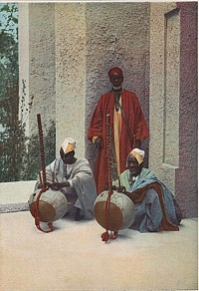

The fact that the blues, or anything remotely sounding like it, does not exist in any other countries in the Americas is thus due to two main reasons: the United States received the highest proportion of men and women from the Sahel, and it is also the only country in the Americas where drumming was strictly forbidden. Whereas Afro-Caribbeans, Afro-Brazilians, or Afro-Uruguayans developed a strong drumming tradition, African Americans did not, and what makes their music so different is precisely the predominance of Sahelian-Islamic elements.
Moreover, the Senegambians quickly adapted to European string instruments such as the fiddle and the guitar. From their lutes they created the banjo, which was later adopted by white musicians. They also continued to fashion the typical instrument of the Mandinka people, the kora, as witnessed by Benjamin Latrobe who saw one at a gathering in Congo Square in New Orleans in 1819.
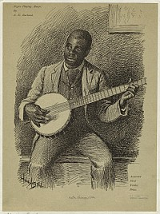

The Emergence of the Blues

When over one million Africans and African Americans, victims of the domestic slave trade (1790s-1865) were transported from the Carolinas, Virginia, and Maryland to the Deep South following the expansion of cotton cultivation, they carried their musical culture to the new territories of Alabama, Mississippi and Texas. There, the individual style of singing typical of the Sahel imposed itself in a new environment where slave gatherings of any sort were being severely suppressed. In such an environment, the Central Africans' collective expressions of culture could hardly survive.
It is in the bleak Deep South that the blues evolved. One of its early ancestors was the field holler. Contrary to the work song, the field holler was sung solo. In 1853, traveler and author Frederick Law Olmsted heard a man in South Carolina raising a "long, loud, musical shout, rising and falling and breaking into falsetto his voice ringing through the woods in the clear, frosty night air, like a bugle call." As noted by historian Sylviane A. Diouf, this type of call brings to mind another call: the Muslim call to prayer, the adhan. Like the adhan, she has shown, the song "Levee Camp Holler," recorded by musicologist Alan Lomax in a Mississippi penitentiary in the 1930s, could have floated from a minaret. Field hollers have the same ornamented notes, tortuously elongated sounds, pauses, humming, melisma, and simple melody as the call to prayer. Traditional blues singer Horace Sprott, born on a plantation in Alabama, recalled hearing the elders sing in that manner in the nineteenth century, and he kept the style alive well into the twentieth century. There is little doubt that African Muslims who continued to pray on the plantations also issued the adhan -- the call to prayer. To non-Muslim whites and blacks, the adhan would have sounded like just another song.

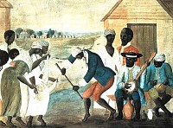

The similarities between the blues and the chanting of the Qur'an are equally strong. Melisma, wavy intonations, and declamation are elements of the traditional style of blues singers. The techniques used by blues guitarists are also similar to those developed in the Sahel, as noted by musicologist John Storm Roberts. The kora, he wrote, is "played in a rhythmic-melodic style that uses constantly changing rhythms, often providing a ground bass overlaid with complex treble patterns, while vocal supplies a third rhythmic layer." Roberts concludes that "similar techniques can be found in hundreds of blues records." Yet, African Muslims were not the only contributors to the blues. For example, sliding the cords of a guitar with a bottleneck and the mouth instrument called the diddley bow all found their origin in Central Africa.
Still, as blues expert Gerhard Kubik emphasizes, "most of the blues tradition in the rural areas of Mississippi has prevailed as a recognizable extension in the New World" of the musical style of the Sahelians. It is one of the most familiar, but also the most hidden and forgotten, contributions of West African Muslims to American culture.

Islam and the Blues - Digging Deeper
Would you like to learn more about this topic? Here are some suggestions for digging deeper:

Books
Charters, Samuel. The Roots of the Blues: An African Search. New York: G. Putnam's Sons, 1981.
Curiel, Jonathan. "Muslim Roots, US Blues." Saudi Aramco World, July/August 2006.
Diouf, Sylviane. Servants Of Allah: African Muslims Enslaved in the Americas. New York: New York University Press, 1998.
Kubik, Gerhard. Africa and the Blues. Jackson: University Press of Mississippi, 1999.
Lomax, Alan. The Land Where The Blues Began. New York: Pantheon, 1993.
Oliver, Paul. Savannah Syncopators: African Retentions in the Blues. New York: Stein and Day, 1970.
Roberts, John Storm. Black Music of Two Worlds. New York: Praeger, 1972.

Online Resources
Afropop interview of Gerhard Kubik
The Origins of the West African Lute

